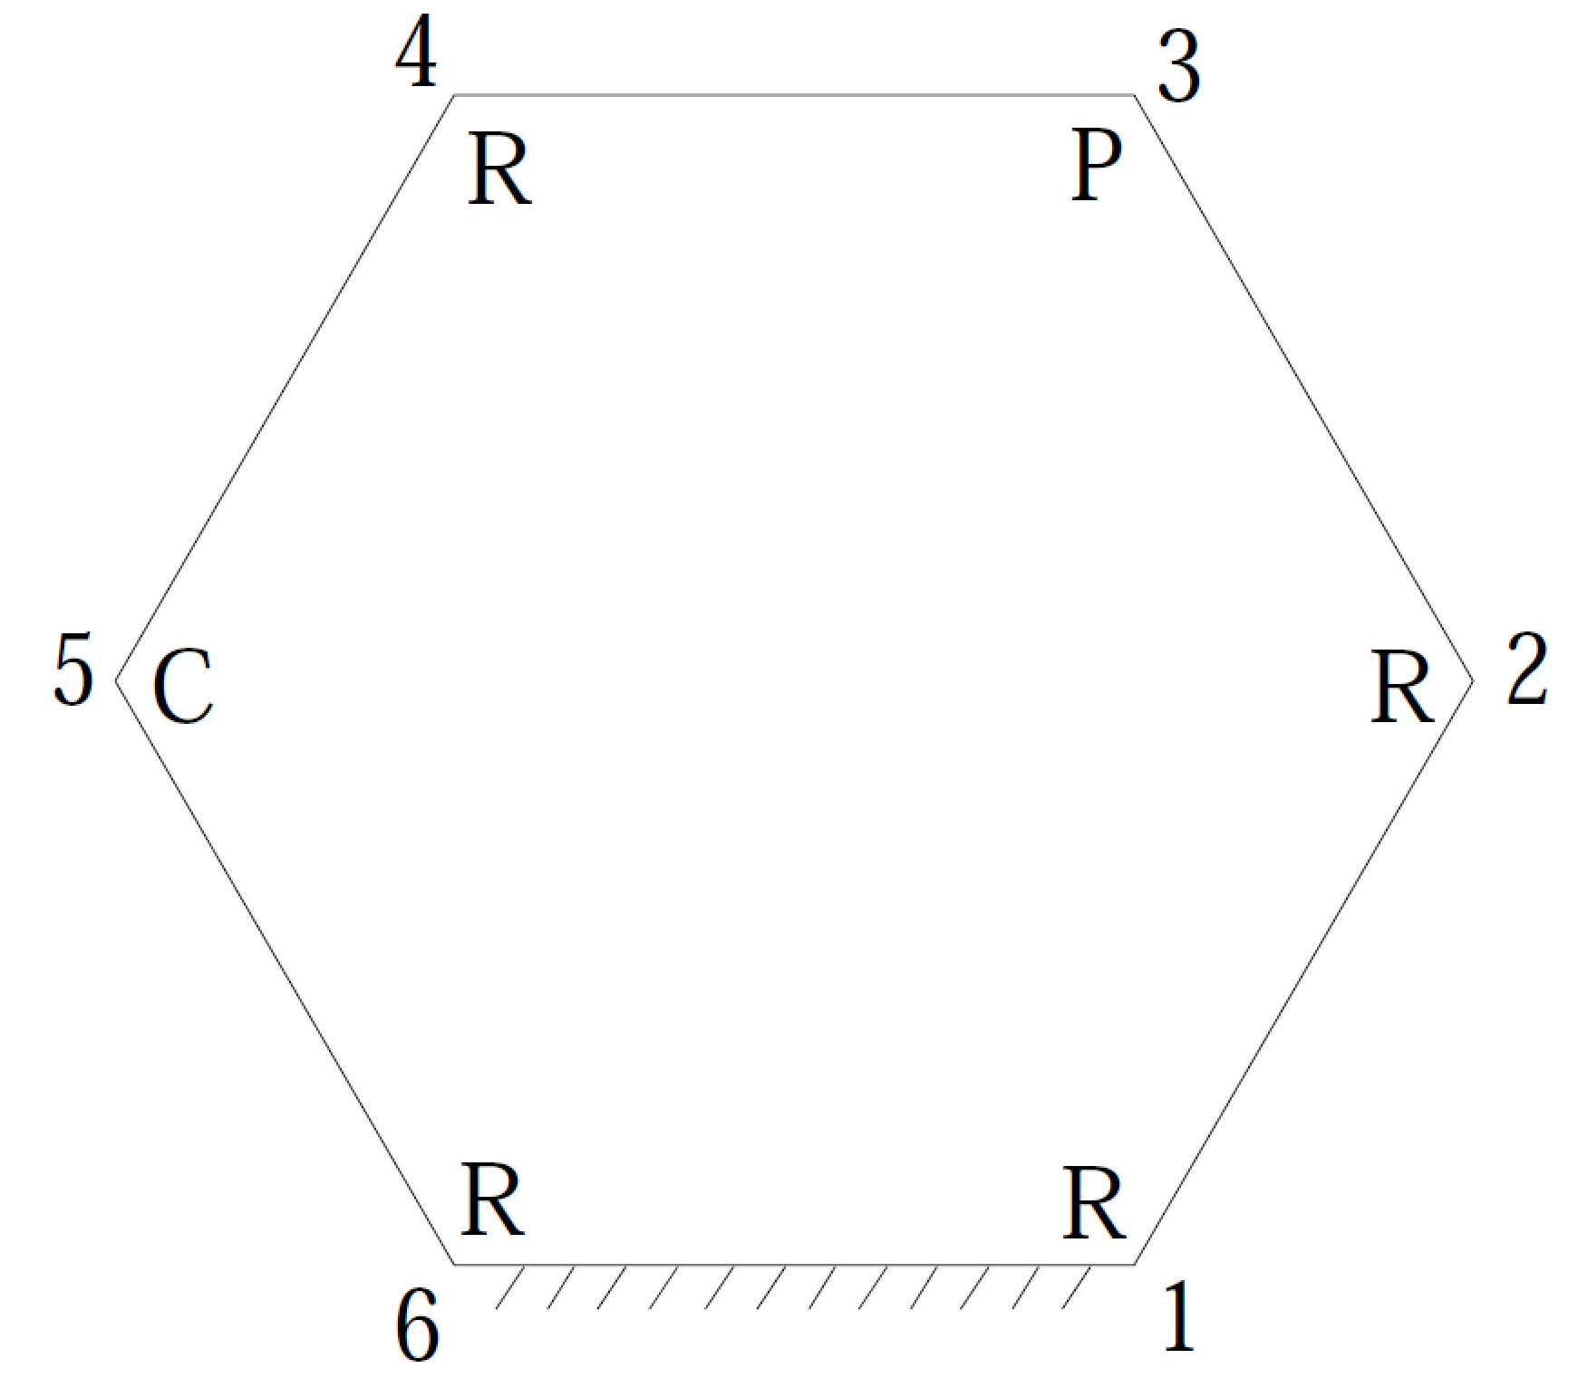

given:

|  |  |  |  |
| --- | --- | --- | --- |
| link lengths, cm | twist angles, deg. | joint offsets, cm | joint angles, deg. |
| S1 = 6.0 | α12 = 47.5 | a12 = 5.5 |  |
| S2 = 4.5 | α23 = 221.0 | a23 = 3.6 |  |
|  | α34 = ~~115.5~~ 115.0 | a34 = 7.2 | θ3 = 90.0 |
| S4 = 7.5 | α45 = 38.5 | a45 = 2.8 |  |
|  | α56 = 295.0 | a56 = 3.8 |  |
| S6 = 3.9 | α61 = 45.0 | a61 = 6.2 | θ6 = 220.0 (input angle) |

find:

θ1, θ2, θ4, θ5

S3, S5